Empathy Map Canvas
ShopEZ — MERN Stack E-commerce Application

Phase: Brainstorming & Ideation Phase
TEAM ID : SWUID2026207177

Classification: Project Documentation — For Academic Submission
Empathy Map Canvas
1
. Introduction
This document presents the Empathy Map Canvas for the two primary user personas of the ShopEZ platform. Empathy mapping is a collaborative design-thinking tool used to articulate a deep understanding of the target users' mental models, motivations, pain points, and desired gains — ensuring that design and development decisions remain grounded in genuine user needs rather than assumptions.
2
. Persona 1 — "The Convenience-Seeking
Shopper"
PERSONA
1
Name:
The Convenience-Seeking Shopper
Profile:

Urban
professional,
24
–40
years
of
age,
technologically
proficient.
Shops online 3–6 times per month across devices (mobile and desktop). Values
speed, security, and a frictionless purchasing experience above all else.
Two distinct personas have been profiled: the Convenience-Seeking Shopper (B2C endconsumer) and the Operationally-Stretched Store Administrator (B2B operator). Each persona is analysed across six dimensions: Think & Feel, Hear, See, Say & Do, Pains, and Gains.

2.1 Empathy Map — Quadrant Chart
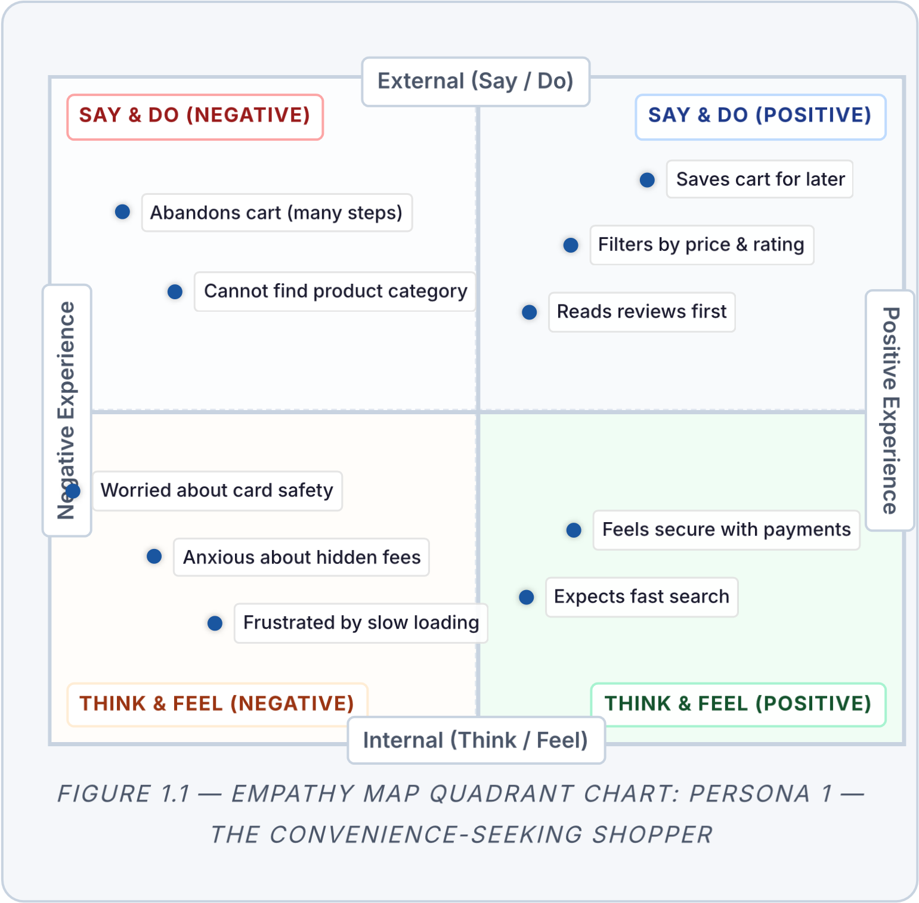

2.2 Detailed Dimension Analysis

🧠 THINK & FEEL
"I hope this website is genuinely secure with my credit card information."
"I need to find what I'm looking for within the first two minutes — otherwise, I'm leaving."
Experiences anxiety regarding undisclosed shipping fees at the final checkout step.
Feels relief and purchase confidence when product pages feature high-resolution images, verified reviews, and clear stock indicators.

👂 HEAR
"You should try this platform — it delivered within 48 hours and the return process was effortless."
"Always check the reviews before committing to a purchase."
"Is the payment integration secure? Did they verify with a gateway?"
Peer recommendations heavily influence first-time platform adoption decisions.

👁

SEE
Competitor platforms with
cluttered, information-dense
product listing pages.
Retargeted advertisements
across social media for
previously-viewed items.
Clean, modern, mobile-first
interfaces on market-leading e-
commerce platforms.
Inconsistent typography and
layout on less-polished
competitor sites.
🗣

SAY
&
DO
"I'll add this to my cart and
complete the purchase on my
laptop later tonight."
"I cannot locate the exact
category I need — the
navigation is confusing."
Frequently abandons checkout
flow when it requires more
than three steps.
Habitually applies price and
rating filters before browsing
product listings.
Reads a minimum of five
reviews before purchasing
above
₹
500.
😣

PAINS
Significant loading delays on
product listing and image-
heavy pages.
Loss of cart items upon session
expiry or when switching
between devices.
Unnecessarily complicated
return/refund and order-
tracking procedures.
Unexpected charges appearing
at the final step of checkout.
😊

GAINS
Time saved through a
streamlined, guided checkout
(
Address
→
Payment
→
Confirm).
Peace of mind from a trusted,
recognisable payment gateway
integration.
High satisfaction when the
search and filter system surfaces
exactly what is needed within
seconds.
3
. Persona 2 — "The Operationally-Stretched
Store Administrator"
PERSONA
2
Name:
The Operationally-Stretched Store Administrator
Profile:

Small-to-medium
business
owner,
30
–50
years
of
age,
moderate
technical proficiency. Manages day-to-day store operations including inventory,
pricing,
and
customer
order
fulfilment.
Time-constrained
and
seeking
efficiency over advanced configuration.

3.1 Detailed Dimension Analysis
🧠

THINK
&
FEEL
"I need to know, at a glance,
how much revenue was
generated this month versus
last."
"Updating product images takes
far too long — I need a faster
image upload process."
Feels overwhelmed when order
status updates require
navigating multiple
disconnected screens.
Concerned about stock
accuracy — fears overselling
when checkout and inventory
are not synchronised in real-
time.
👂

HEAR
"You need a dashboard that
shows your numbers clearly —
not buried in spreadsheets."
"Customers are complaining
that product images are low
quality and take ages to load."
"You should be able to add a
product listing in under two
minutes."
👁

SEE
Competitors using integrated
admin panels with real-time
analytics widgets.
Their own sales data trapped in
manual, error-prone
spreadsheet exports.
E-commerce SaaS platforms
with high monthly
subscription costs.
🗣

SAY
&
DO
"Every time I upload a new
product, I need to manually
resize and host the images."
"I have no way to see which
products are underperforming."
Spends disproportionate time
on repetitive admin tasks that
should be automated.
Delays fulfilling orders because
the order list interface is
difficult to parse.
😣

PAINS
No centralised dashboard
presenting aggregated sales
metrics and order statuses.
Image management is a
significant operational
bottleneck without CDN
support.
Inability to quickly identify
low-stock items before they go
out of stock.
😊

GAINS
A dedicated, secure
/admin
panel with role-protected
access.
Cloudinary-powered image
uploads that auto-optimise and
serve via CDN.
Sales analytics (monthly
revenue charts, order volume
trends) at a glance.
One-click order status updates
Processing
(
→
Shipped
→
Delivered).

4. Persona Comparison Summary
Dimension | Persona 1 — B2C  Shopper | Persona 2 — Store  Administrator
Primary Goal | Find and purchase products quickly and securely | Manage inventory and monitor business performance efficiently
Core Pain | Cart loss, slow site, confusing checkout | No analytics dashboard, manual image handling
Core Gain Streamlined checkout, Cloudinary CDN, real-time trusted payment sales metrics gateway
Platform  Feature  Needed |  | Search & Filter,  Persistent Cart, 3-step  Checkout | Admin Panel, Cloudinary  Upload, Revenue Charts
 | Tech Enabler | React SPA + MongoDB  Cart + Stripe/Razorpay | Node.js Admin API +  Cloudinary + MongoDB
Aggregation
5
. Conclusion
The empathy maps for both personas reveal a shared underlying theme: the demand for speed, trust, and operational efficiency. The B2C Shopper requires a fast, transparent, and secure purchasing experience. The Store Administrator requires a centralised, automated operations platform. Both sets of needs are systematically addressed by the ShopEZ feature set, as validated in the Problem–Solution Fit and Requirement Analysis documents. Every platform feature should be evaluated against its contribution to resolving at least one documented Pain or enabling at least one documented Gain for these two primary personas.
ShopEZ MERN E-commerce Application · Brainstorming & Ideation Phase · Empathy Map
Canvas

